**Disaster Zone Designs Supporting Documentation**

**Introduction**

Disaster Zone will be a survival app targeted at the public (16+) that is designed to help people survive all types of natural disasters. In order to make sure that the app is user friendly we must ensure that the app is well designed and conforms to Googles Android Material Design as it will help us produce an app that is familiar to the average Android user. Within this document, you will find the screen designs we have come up with as well as a short description of how the app is intended to be used so let’s begin.

**Home Screen**

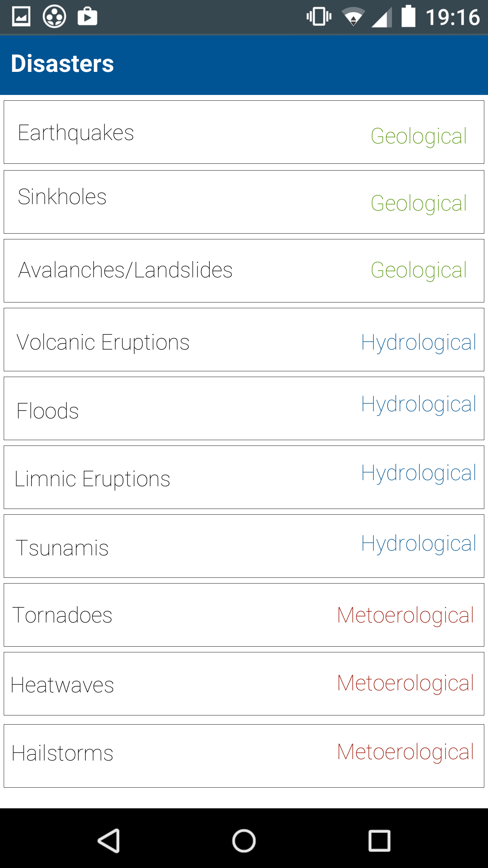

As the app has been designed to conform to the Android Material Design Guidelines it is very similar in layout and design to other Android apps. The purpose of this is to make the app user friendly, for example an Android user will instinctively know that they can scroll up or down the list with their finger. They will also realise that they can tap on any of the disasters they want to get more information and move onto the next screen.

The home screen is the first screen the user will see after they launch the app so it is important to make sure that the app is not intimidating to a new user, therefore we have decided to keep the screen simple and to display the options in a simple list format. As you can see we have separated each disaster into its corresponding category on the right side of the options, we have also colour coded the categories to make it easier for the user to quickly find the category they are looking for. We have also kept the design simple so that a new user will instinctively know to scroll up or down the list using their finger, the user will also instinctively know to press on the option they want as the app has been designed to conform with the Android Material Design guidelines.

**Disaster Information Screen**

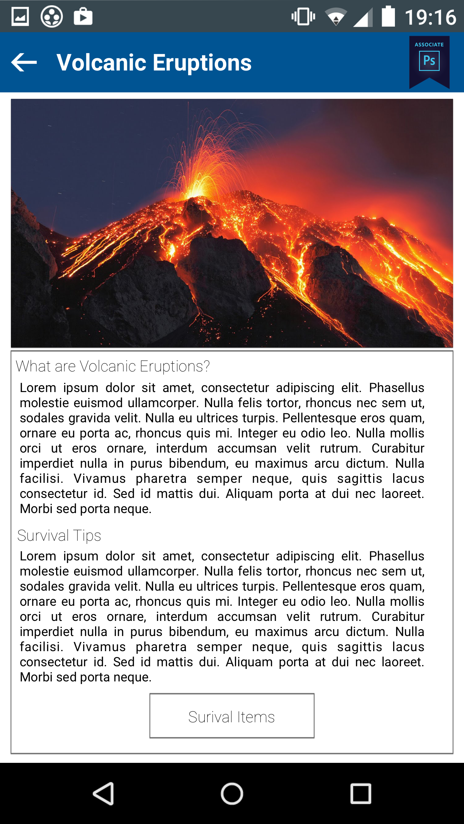

On this screen, the user will be presented with a short description of their chosen disaster as well as our survival tips. The user can then either go back to the previous screen with the back arrow at the top left of the screen or view relevant survival items using the ‘Survival Items’ button at the bottom of the page.

Once the user has selected a disaster they will be greeted by the ‘Disaster Information Screen’ where they will be able to view a short description of their chosen disaster followed by our survival tips. The ‘Lorem Ipsum’ text you see in the screen designs are just place holder text in the final app the text will be changed according to the disaster. Included on this screen is a back button on the top left to allow the user to return to the previous screen, we have also included a button at the bottom of the page to allow the user to view the relevant survival items for that particular disaster. As you can see we have tried to keep the design consistent to avoid confusing the user, if this screen was drastically different from the last it would only serve to confuse the user which is something we want to avoid in our designs.

**Survival Items Screen**

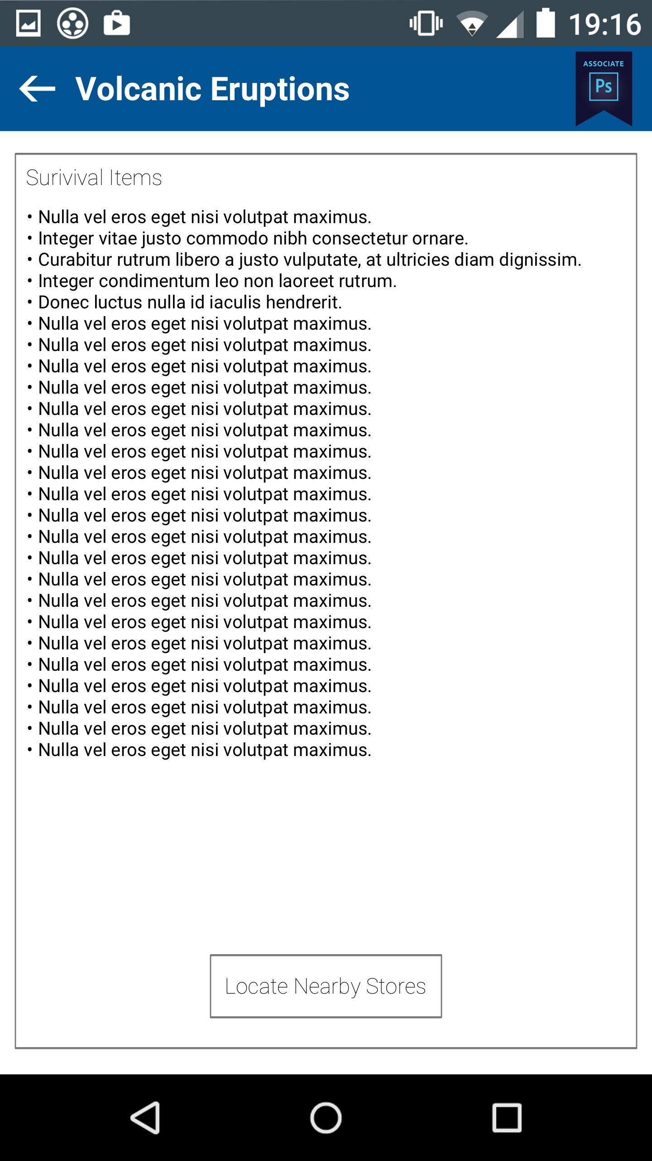

The purpose of this screen is to display survival items related to the users chosen disaster, the user can then decide to locate nearby stores that stock these items. The purpose of this is to help the user prepare for a disaster, for example if the disaster was a blizzard items such as blankets and heaters would be displayed here.

The ‘Survival Items’ screen is a fairly simplistic screen as its purpose is just to list the survival items related to the chosen disaster, of course in the real app the list will be a different size depending on the disaster. As with the previous screens we have tried to keep the design consistent in order to promote confidence with the user so they feel the app is easy to use and navigate, again we have a button at the bottom of the screen and a back button located at the top left.

**Nearby Stores Screen**

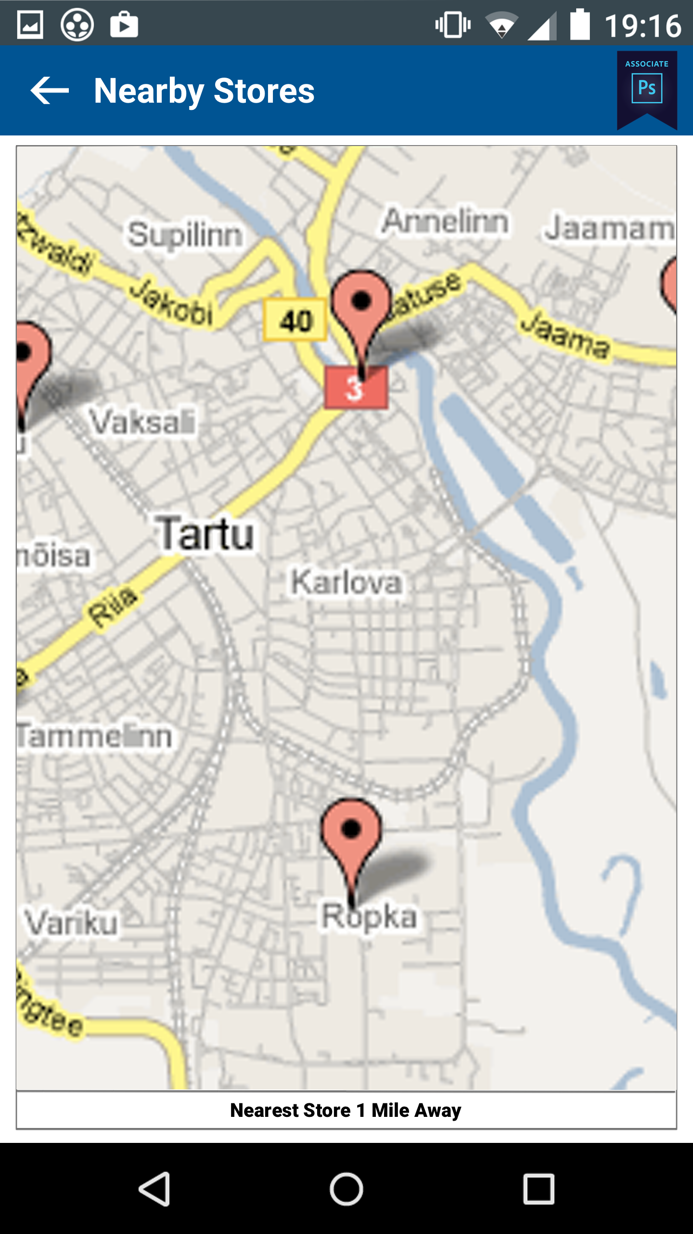

The final screen in our app will display the locations of nearby stores that stock the items that the user will need to prepare for their chosen disaster. Again we have tried to keep the design consistent to promote usability within our app.

The final screen is probably the most simplistic as it displays a Google Maps widget that shows all the nearby stores that stock the items from the previous screen. The purpose of this is to show the user where to buy the items we recommend so they can prepare for the chosen disaster.

\***All screen designs are designed for the Samsung Galaxy S7 Screen Size (2560x1440). The actual app will scale to the screen size of the user’s device.**

**References:**

Android Material Design (n.d) [online] available from < <https://developer.android.com/design/material/index.html> > [19 February 2017]

Lipsum (n.d) [online] available from < <http://www.lipsum.com/> > [19 February 2017]